1. **Experiment:** Flow Cytometric Analysis of NK Cell PFN & GrB
2. **Time:** 2025.05.10-2025.05.29
3. **Member:** Xudong Tang, Yang Jin, Binxuan Zhang, Kaiqing Zhang, Xuantong Liu
4. **Materials:** Flow cytometer, Anti-human Perforin antibody (BioLegend, 308104), Anti-Human Granzyme B Antibody (BioLegend, 515404),Ice-cold PBS Staining buffer, Brefeldin A, 4% paraformaldehyde (PFA), 0.1% Triton X-100
5. **Method:**
6. **Cell preparation:**
7. NK cells pre-activated by B34G35R, B51G35R, and B51G9 are collected from previously proliferated cells and Co-cultured with target cells (K562) in logarithmic growth phase with effector cells (pre-stimulated NK cells) at a specific effector-to-target ratio in a 37 °C, 5% CO₂ incubator.
8. Add Brefeldin A (diluted 1:1000) to the co-culture system 12 hours after initiation. Continue culture for a total of 46 hours.
9. After co-culture, collect cells into flow cytometry tubes. Wash once with pre-chilled PBS, centrifuge at 300 × g for 5 minutes, and discard the supernatant.
10. Resuspend cells in 100 μL flow cytometry staining buffer for cell counting.
11. **Surface Staining**
12. Dosage example for a 100 μL reaction system: CD3-PerCPCy5.5 (1:100), CD56-PE (1:100).
13. Add antibodies to the cell tube, gently mix by pipetting, and incubate at 4 °C in the dark for 30 minutes.
14. Wash with 2 mL staining buffer, centrifuge at 300 × g for 5 minutes, and discard supernatant. Repeat washing once.
15. **Fixation and Membrane Permeabilization**
16. Resuspend cells in 100 μL fixative, incubate at room temperature in the dark for 15-20 minutes.
17. Add 2 mL staining buffer, centrifuge, discard supernatant, and thoroughly remove fixative.
18. Resuspend cells in 100 μL lysis buffer and incubate at room temperature in the dark for 15-20 minutes.
19. **Intracellular Staining**
20. Dilute intracellular antibodies in lysis buffer: Perforin-FITC (1:20), Granzyme-BV421 (1:20), centrifuge and discard lysis buffer.
21. Add the intracellular antibody cocktail to the cell tube, gently pipette to mix, and incubate at room temperature in the dark for 30-45 minutes.
22. Wash with 2 mL lysis buffer, centrifuge at 300 × g for 5 minutes, and discard the supernatant. Repeat the wash once.
23. Resuspend cells in 300-500 μL flow cytometry staining buffer and analyze immediately.
24. **Data Analysis:**
25. The suspension was transferred to flow cytometry sample tubes.
26. Analysis Strategy:

Gate to exclude doublets (using FSC-A vs FSC-H).

Gate to exclude dead cells (using a viability dye).

Identify the target cell population (NK cells: CD3⁻ CD56⁺).

Analyze Perforin and Granzyme B expression: Percentage of positive cells (%) and Mean Fluorescence Intensity (MFI).

1. **Result:**

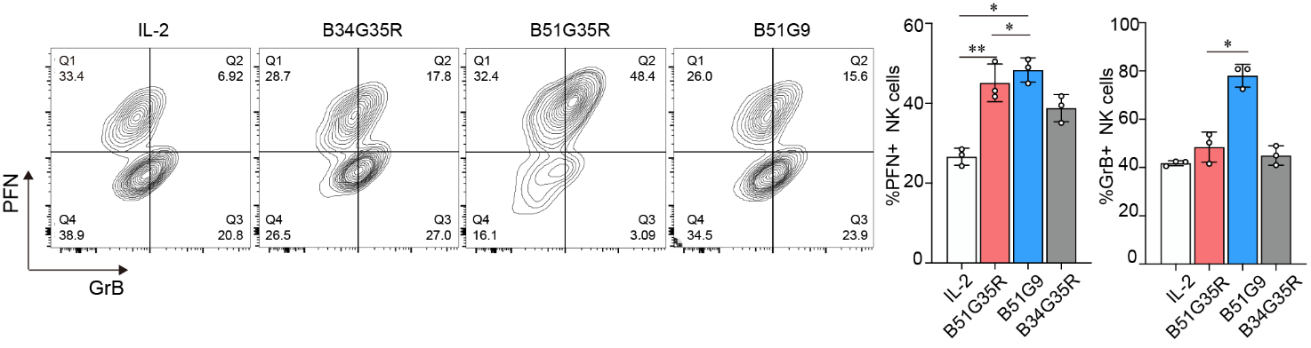

**Figure.1** Killing activity of NK cells and T cells pre-stimulated by IL-2 (control), B34G51, B34G35, B51G9. The PFN and GrB expression levels were assessed by flow cytometry. Data are representative of at least three independent experiments (\*\**P* < 0.01, \**P* < 0.05).